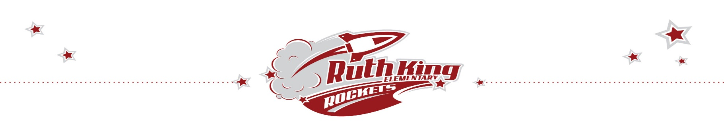
* RESPECT * OWNERSHIP * CARING * KINDNESS * SAFETY

Journeys of the Heart- Program Description

Journeys of the Heart is a “FREE-OF-CHARGE” 10 month (30 week) cultural early learning program for Aboriginal children ages 2-5 years and their families. Program structure and delivery is designed to provide opportunities to empower and contribute to positive cultural identity within Aboriginal children and their families. Local Aboriginal cultural has been incorporated throughout the programs activities as well as knowledge from Nations across Canada. Aboriginal knowledge encourages a sense of pride and supports a positive learning experience. Since Journeys of the Heart believes in the strengths of caregivers as primary teachers, the program is designed to involve them in the learning/teaching process.
Through out the 10 months, Journeys of the Heart strives to nurture a child’s cultural identity while preparing and providing children and caregivers with skills and tools to promote a positive transition into the public school system. Journeys of the Heart has incorporated Seeds of Empathy, which fosters the development of empathy and emotional literacy. It also includes Moe the Mouse, an innovative early speech and language resource that uses Aboriginal toys and stories to enhance language development.
LOCATIONS & TIMES:
NEW LOCATION: Ruth King Elementary, Monday & Wednesday 9:00am-11:30am
• A 1:00pm – 3:30pm class will be added once registration picks up
Craigflower Elementary, Tuesday & Thursday, 9:00am – 11:30pm & 1:00pm – 3:30 pm

For more information or to register, please contact Jackie Moffatt at 250-384-9466 Ext. 251 or Julia Clifton at 250-384-9466 Ext. 250 at Hulitan Family and Community Services Society.

